ECE Lab #4

Seth H Evans

5/3/22

Introduction
The purpose of Lab 4 is to create a schematic that utilizes the FPGA board in such a way that a clock is used to increment values of a bit in correlation to which switch is being turned on. For example, for the switch that I assign to be the first, if i told that switch 1 to be on while I hit the clock button, it should increase from 0 to 1. Instead, if were to start on switch 2, the next switch over to the right, and hit the clock button, my hexidecimal value displayed on the seven-segment display would increase by 2, resulting in a chnage from 0 to 2. The possible values to be displayed include numbers 0-9, and hexidecimal letter A-G. We discovered how to derive these values from the Terasic hardware through lab 3. We are using schematics from previous labs in order to combine them to make something a little more complex. In this lab, we are able to establish memory by using sequential logic that knows of what prior stage has been executed or not.. We would not be able to do this with combinational logic. We achieve this by utilizing a D flip-flop.
In this schematic for Lab 4, we cmbine the use of the AND gate logic used in the hexidecimal lab 3, and combining the adders from lab 2, and our knew knowledge of registers and flip flops in order to increment a clock which can change our hexi value at the click of a button. I found it useful to implement the RESET as another input that was optional. I found this useful, as the second button, it could reset the hexidecimal to zero at any point between any switch of any complement.

Design

We want to be able to use those 4 switches individually, only working one at a time. When we set one of four switches to active high, we are in that given switches mode. The two buttons on the right act as action you can perform at any time. (whilst in a switch mode) :
SWTCH: Show next variable
RESET: Restart mode to 0

✋For each switch I show a color coding that is meant to show its associated complements if the switch was activated. This is NOT to say that more than one seven-segment display is on. Rather it is meant to show what value may go in place of the rightmost display.
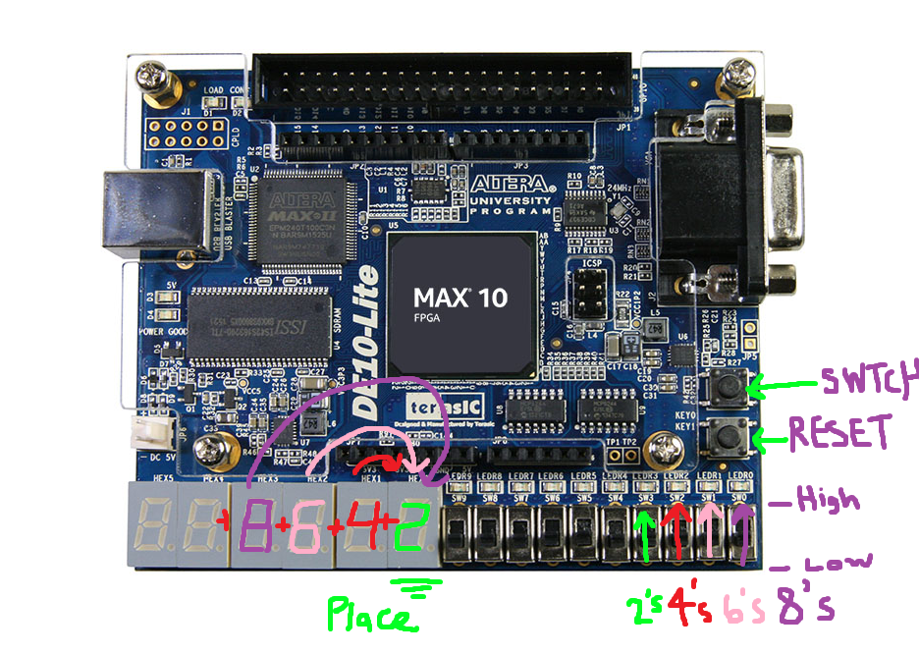

We know that we need to utilize a D-flop in order to have an input (D) that is evaluated at every change in order to check and see if it needs to either be increased or set to zero. The full top-level schematic is derived from using the block diagrams made in Labs 2 and 3, combined with a register that utilizes D flip- flops to create memory of bits.

Interface Name | Interface Purpose | Input or Output | Number of Pins | Active High or Low | Board Label | FPGA Pin
CLK | Gate input | Input | 1 | Schmitt trigger-High | Key 0 | B8
RESET | Gate input | Input | 1 | Schmitt trigger- High | Key 1 | A7
AddBy[0] | +1 mode | Input | 1 | High | SW3 | C12
AddBy[1] | +2 mode | Input | 1 | High | SW2 | D12
AddBy[2] | +3 mode | Input | 1 | High | SW1 | C11
AddBy[3] | +4 mode | Input | 1 | High | SW0 | C10
Seg[A:G] | Turn on segment | Out | 7 | Low | HEX:1,2,3,4,5,6,7 | C14,E15,C15,C16,E16,D17,C17

The full schematic:
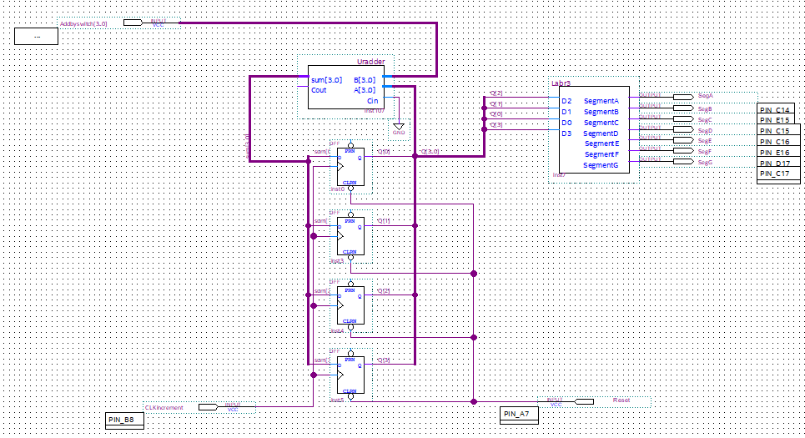
Using an adder, register, clk increments, and a reset, we can out put the sum of values to a decoder that displays the determiend value on the seven segment display. The adder takes makes our binary complements change varying by switch. The registers job is to take an action from the user at any moment, while also accountng for the current state of the resulting sum, D. The clk increments represents the action from the user. The reset is the last action possible from the user, and that is to restart any given switch mode back to the very beggining, zero.

The adder1 schematic:

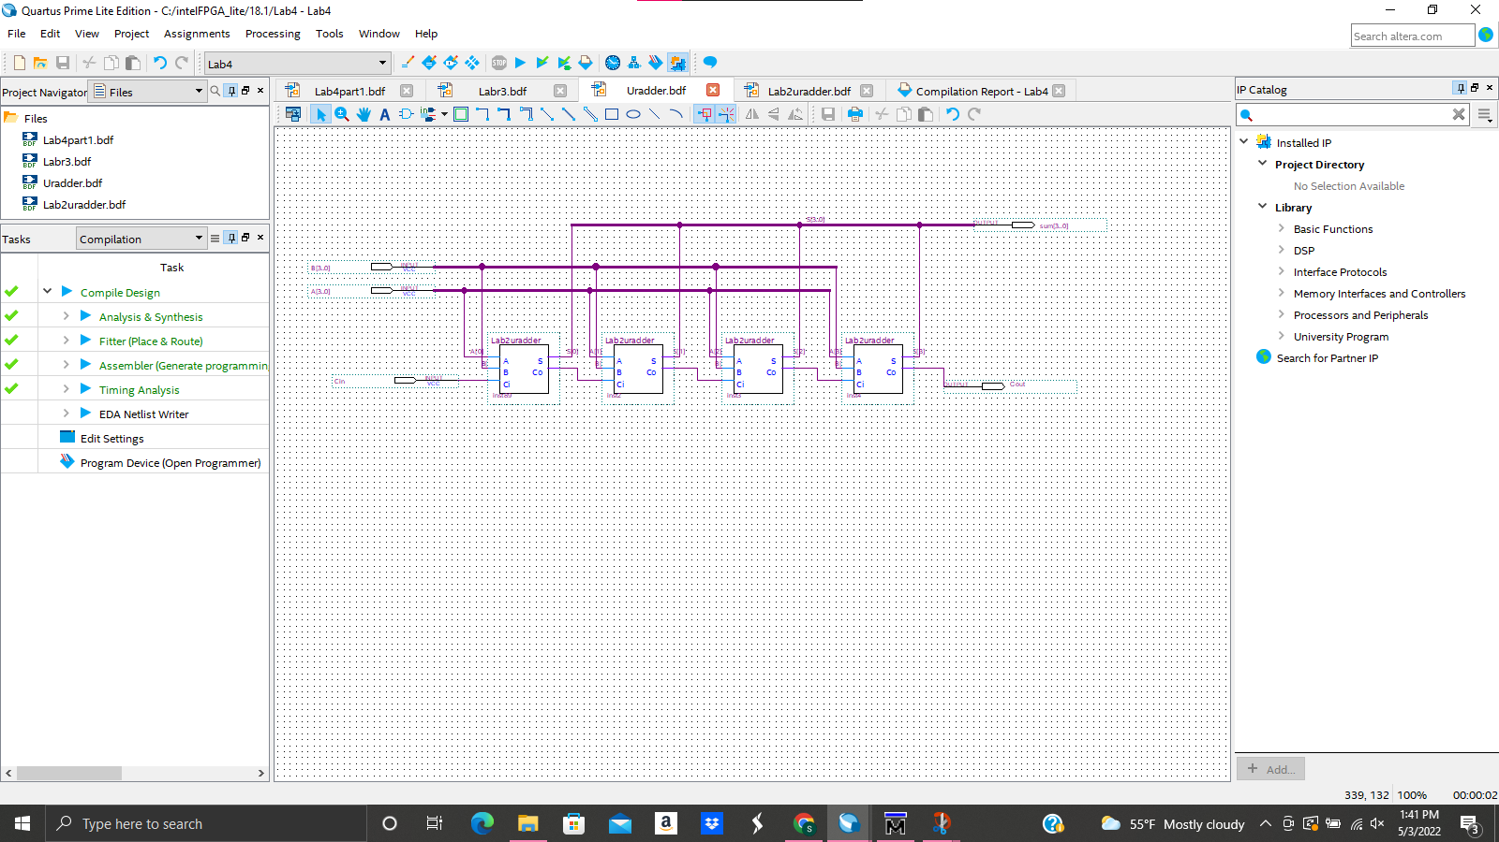
Here we see a closer look at the adder used for A and B. We can see that it establishes memore by utilizing adders in such a way that we have adders with not only 3 inputs, one of which is dependet on the rpevious, but also 2 outputs, which help determine the neighbouring adder. This forms ‘memory’ using sequential logic.

Individual adders in the adder1 schematic:
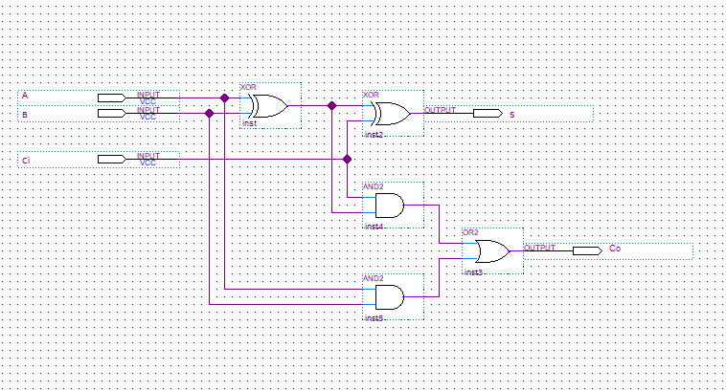
A deeper delve into the adders used within adder1, show that we are using two xor gates as well as two AND gates with an Or gate in order to define a function that takes 3 inputs, and determines two outputs.

The pin assignments
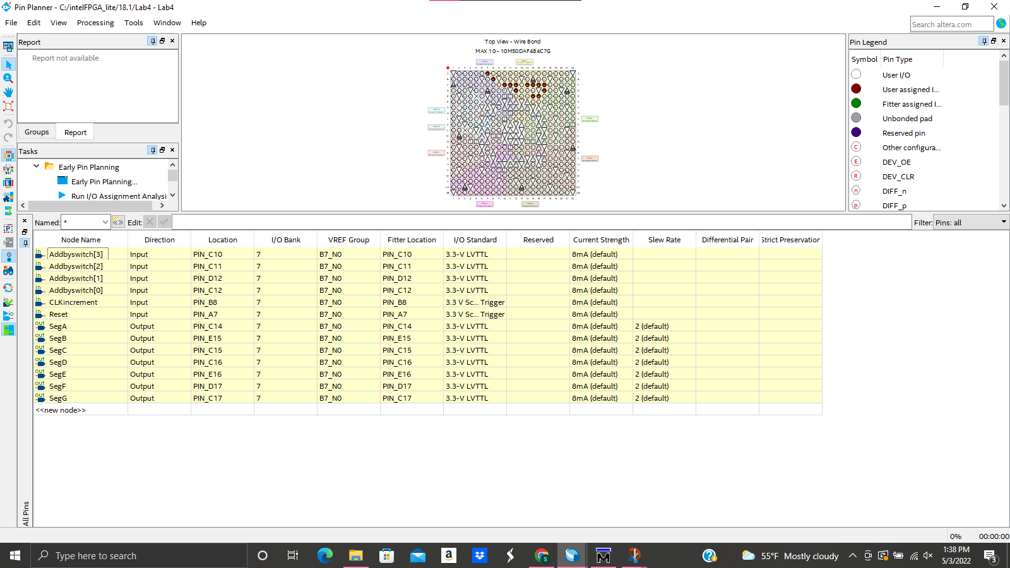
The Addby are derived from switches, both CLK and Reset are the two buttons on the FPGA, and the Segments light up the display in the proper oder to display a decimal or letter.
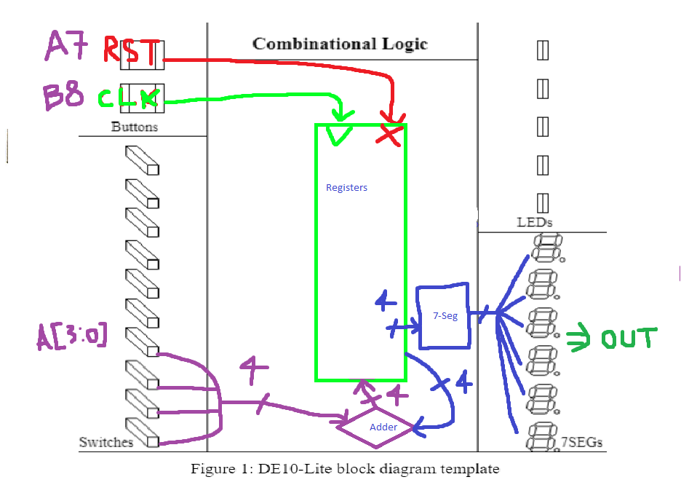
.
Figure 1: DE10-Lite block diagram template

Results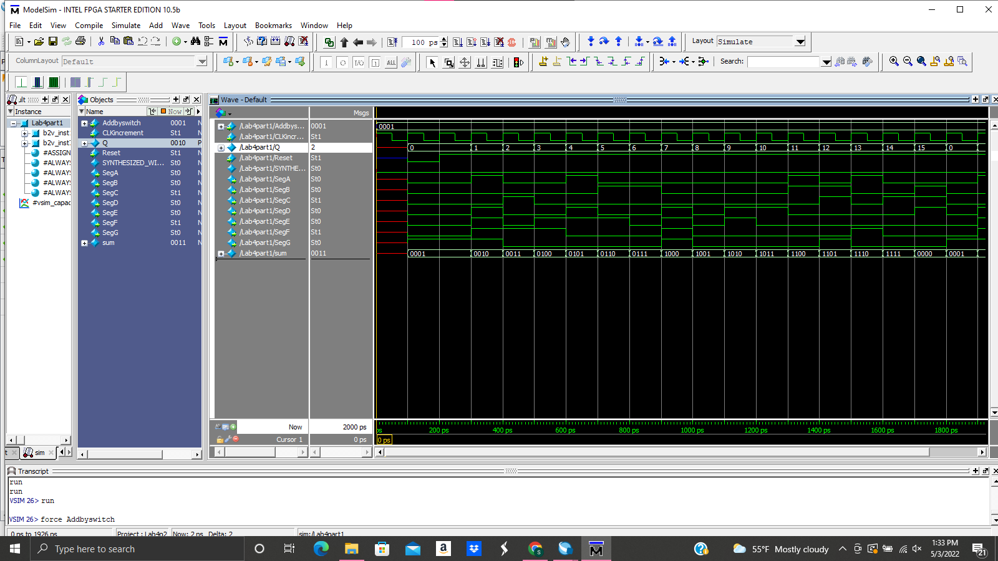
...

Experiment Notes
In this section, write a brief paragraph explaining what went well and what did not go well in this lab. These are perhaps the easiest points you’ll earn in this lab report. Just talk about what happened, how it went.
The lab went very well for me, as it was a great chance for me to learn and get some experience time in. The lab took me about 6 hours with lots of help, so it was not an easy task for me. There were may things that slowed my progression and required either help or critical thought. I had many issues with error checking whiole compiling. The errors had to do with my syntax and illegal usage of ‘inst’ names and using “[D:0]” for bus names, when I had to change it to the proper synatx, “[D.0]”. The barrier from design to hardware defintion was a learning curve for me, I did not know when Quartus cares for what I name node lines, bus lines, inputs, outputs etc. i thought it did not care about how I named busses specifically, but we soon found out that not only was I making syntax errors, but I had logic errors. Even though my bdf finally compiled, I was still not getting the proper result on the FPGA board, and the reason for that lied in that I had made another msiatke on not knowing how specific quartus wants the bus names to be, and I had accidentally mix matched my node’s to the incorrectly corresponding inputs on the decoder, resulting in faulty binary that would increment the values, but out of sequential order.

Study Questions

What is an alternate method of designing a counter with digital logic?
We traditionally used a syncrhonous counter, but we could have used a decade counter, where you tell the system to count 10 different staes then reest it back to the default state. A decade counter could range from 0-15 values for a 4-bit counter.

What functions do the DFF ports PRN and CLRN perform?
The PRN and CLRn ports are noth asynchrounous iinputs that are used to turn the flip-flop on or off without the need of any clock signal. PRN stands for “PReset, negated”, meaning that the system is shut off from contact with the input and thus set back to default. CLRN’s stand for “CLeaR, Negated” which means to change into the next given stage. The DFF port allows you to program an edge triggered register in a D flip-flop.

How would this functionality be used to implement a reset?
The functionality of these ports may be used a s away to take your inputs and have the capability of doing two things to these variables:
You could let the adder continue (CLRN)
You could reset the value back to its initial valued register (PRN)
That being said, the PRN represents a reset, or in other words a restart to the sequential process. These resets only apply when after the DFF has an edge trigger that carries on for enough picoseconds to capture a PRN that would then cause a change in the stage OR a advancement in CRN.

